Date | 30/10/2025
Time id | NM2025TMID05890
Project name | Calculating Family Expenses using Service Now
Maximum mark | 4 marks
PROJECT DESIGN PHASE
Data Flow Diagram & User Stories

Data Flow Diagram (DFD) – Calculating Family Expenses
The DFD illustrates how data moves through the Family Expense Management System to streamline budget tracking and analysis.
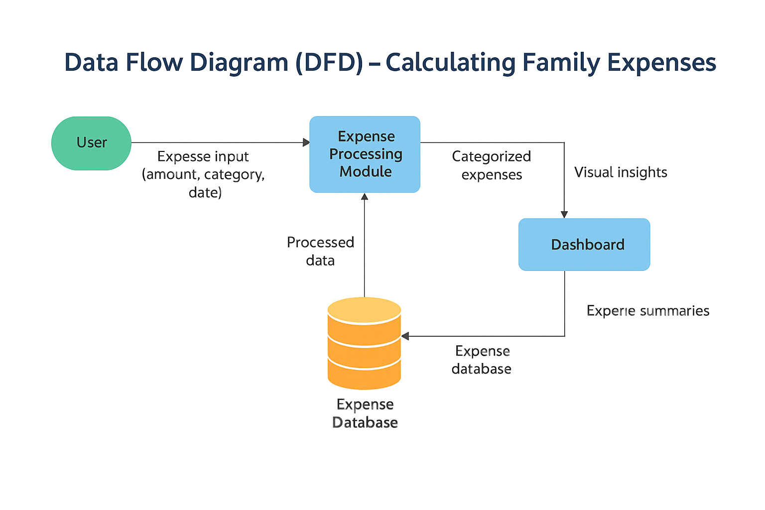
Level 0 (Context Diagram):
- User inputs income and expenses → Expense Management System → outputs reports and summaries back to the User.
Level 1 (Detailed Flow):
- User enters expense details (amount, category, date).
- Data goes to Expense Processing Module for validation and categorization.
- Processed data is stored in the Expense Database.
- Report Generator fetches data to create monthly or yearly summaries.
- Dashboard displays visual insights (charts, comparisons, savings tips).

User Stories – Calculating Family Expenses
User stories are short, simple descriptions of a feature told from the perspective of the end user. They define what the user needs and why, helping guide development toward delivering real value and solving user problems.
S.No | User Story | Description | Priority | Story Points
1 | As a user, I want to add my monthly income | So that I can calculate savings after expenses | High | 3
2 | As a user, I want to categorize expenses (food, rent, transport, etc.) | To understand where most money is spent | High | 5
3 | As a user, I want to set spending limits per category | So that I can control overspending | Medium | 3
4 | As a user, I want to view a summary chart of my expenses | To visualize and analyze my spending pattern | High | 5
5 | As a user, I want to edit or delete an expense entry | So that I can correct any mistakes | Medium | 2
6 | As a user, I want to generate a monthly report | To review my financial performance | Medium | 3
7 | As a user, I want to receive alerts when nearing spending limits | To maintain financial discipline | Low | 2
8 | As a user, I want data to be securely stored and backed up | To ensure I don’t lose my records | High | 4

